M.Sc (IMCA)

2020-2021 SEMESTER IV

MTS5410 Experimental Training on WEB UI & UX Assignment 7: CSS - 4

**Q1**.Design the following Home Page for the Website. (Use External CSS). (Any Background Image can be used.)

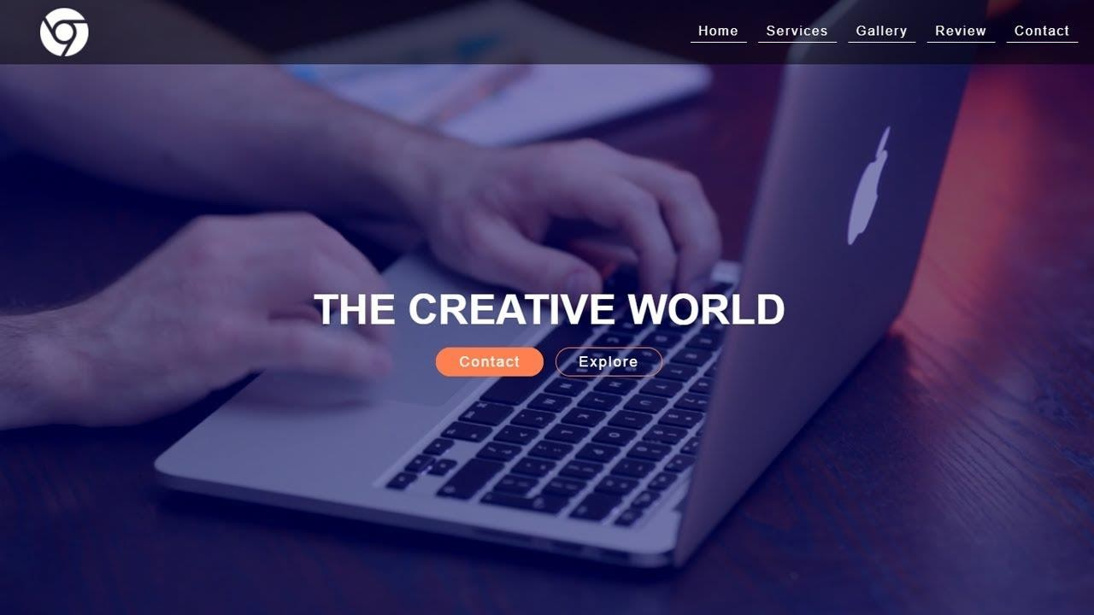

Image Reference : https://i.ytimg.com/vi/PqVZTYxF0hk/maxresdefault.jpg